**SIMPLE LINEAR REGRESSION**

import numpy as np

import pandas as pd

import matplotlib.pyplot as plt

 dataset = pd.read_csv('Salary_Data.csv')

dataset.head()

 X = dataset.iloc[:,:-1].values  #independent variable array

y = dataset.iloc[:,1].values  #dependent variable vector

 from sklearn.model_selection import train_test_split

X_train, X_test, y_train, y_test = train_test_split(X,y,test_size=1/3,random_state=42)

 from sklearn.linear_model import LinearRegression

regressor = LinearRegression()

regressor.fit(X_train,y_train) #actually produces the linear eqn for the data

 y_pred = regressor.predict(X_test)

y_pred

 y_test

 print('Train Score: ', regressor.score(X_train, y_train))

print('Test Score: ', regressor.score(X_test, y_test))

 #plot for the TRAIN

 plt.scatter(X_train, y_train, color='red') # plotting the observation line

 plt.plot(X_train, regressor.predict(X_train), color='blue') # plotting the regression line

 plt.title("Salary vs Experience (Training set)") # stating the title of the graph

 plt.xlabel("Years of experience") # adding the name of x-axis

plt.ylabel("Salaries") # adding the name of y-axis

plt.show() # specifies end of graph

 #plot for the TEST

 plt.scatter(X_test, y_test, color='red')

plt.plot(X_train, regressor.predict(X_train), color='blue') # plotting the regression line

 plt.title("Salary vs Experience (Testing set)")

 plt.xlabel("Years of experience")

plt.ylabel("Salaries")

plt.show()

**OUTPUT:**

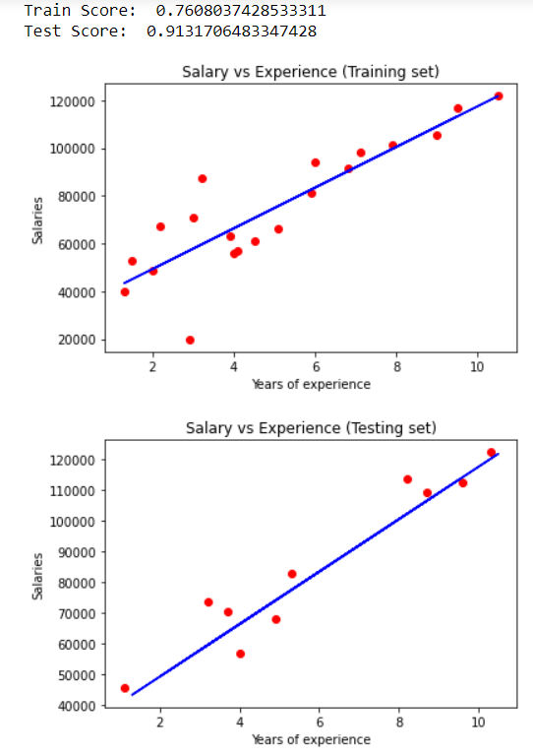

**MULTIPLE LINEAR REGRESSION**

import numpy as nm

import matplotlib.pyplot as mtp

import pandas as pd

#importing datasets

data_set= pd.read_csv('50_Startups.csv')

data_set

#Extracting Independent and dependent Variable

x= data_set.iloc[:, :-1].values

y= data_set.iloc[:, 4].values

print(x)

print(y)

from sklearn.preprocessing import LabelEncoder, OneHotEncoder

from sklearn.compose import ColumnTransformer

# State column

ct = ColumnTransformer([("State", OneHotEncoder(), [3])], remainder = 'passthrough')

X = ct.fit_transform(x)

 X

 x = X[:, 1:]

 x

 # Splitting the dataset into training and test set.

from sklearn.model_selection import train_test_split

x_train, x_test, y_train, y_test= train_test_split(x, y, test_size= 0.2, random_state=0)

from sklearn.linear_model import LinearRegression

regressor= LinearRegression()

regressor.fit(x_train, y_train)

#Predicting the Test set result;

y_pred= regressor.predict(x_test)

print(y_pred)

print(y_test)

print('Train Score: ', regressor.score(x_train, y_train))

print('Test Score: ', regressor.score(x_test, y_test))

**OUTPUT:**



**LOGISTIC REGRESSION**

import pandas as pd

import numpy as np

import matplotlib.pyplot as plt

dataset = pd.read_csv('User_Data.csv')

dataset.head()

# input

x = dataset.iloc[:, [2, 3]].values

# output

y = dataset.iloc[:, 4].values

from sklearn.model_selection import train_test_split

xtrain, xtest, ytrain, ytest = train_test_split(

        x, y, test_size = 0.25, random_state = 42)

from sklearn.preprocessing import StandardScaler

sc_x = StandardScaler()

xtrain = sc_x.fit_transform(xtrain)

xtest = sc_x.transform(xtest)

print (xtrain[0:10, :])

from sklearn.linear_model import LogisticRegression

classifier = LogisticRegression(random_state = 42)

classifier.fit(xtrain, ytrain)

y_pred = classifier.predict(xtest)

print(y_pred)

from sklearn.metrics import confusion_matrix

cm = confusion_matrix(ytest, y_pred)

print ("Confusion Matrix : \n", cm)

from sklearn.metrics import accuracy_score

print ("Accuracy : ", accuracy_score(ytest, y_pred))

from matplotlib.colors import ListedColormap

X_set, y_set = xtest, ytest

X1, X2 = np.meshgrid(np.arange(start = X_set[:, 0].min() - 1,

                               stop = X_set[:, 0].max() + 1, step = 0.01),

                     np.arange(start = X_set[:, 1].min() - 1,

                               stop = X_set[:, 1].max() + 1, step = 0.01))

plt.contourf(X1, X2, classifier.predict(

             np.array([X1.ravel(), X2.ravel()]).T).reshape(

             X1.shape), alpha = 0.75, cmap = ListedColormap(('red', 'green')))

plt.xlim(X1.min(), X1.max())

plt.ylim(X2.min(), X2.max())

for i, j in enumerate(np.unique(y_set)):

    plt.scatter(X_set[y_set == j, 0], X_set[y_set == j, 1],

                c = ListedColormap(('red', 'green'))(i), label = j)

plt.title('Classifier (Test set)')

plt.xlabel('Age')

plt.ylabel('Estimated Salary')

plt.legend()

plt.show()

OUTPUT:

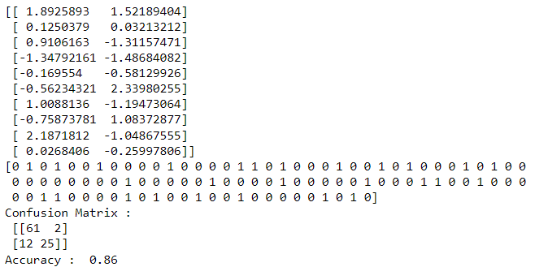

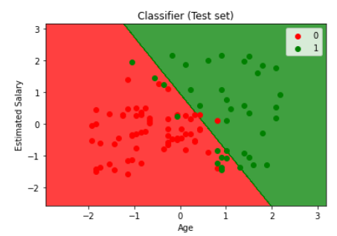

**OR GATE**

import numpy as np  
    
# define Unit Step Function  
def unitStep(v):  
    if v >= 0:  
        return 1  
    else:  
        return 0  
# design Perceptron Model  
def perceptronModel(x, w, b):  
    v = np.dot(w, x) + b  
    y = unitStep(v)  
    return y  
# OR Logic Function  
# w1 = 1, w2 = 1, b = -0.5  
def OR_logicFunction(x):  
    w = np.array([1, 1])  
    b = -0.5  
    return perceptronModel(x, w, b)  
    
# testing the Perceptron Model  
test1 = np.array([0, 1])  
test2 = np.array([1, 1])  
test3 = np.array([0, 0])  
test4 = np.array([1, 0])  
    
print("OR({}, {}) = {}".format(0, 1, OR_logicFunction(test1)))  
print("OR({}, {}) = {}".format(1, 1, OR_logicFunction(test2)))  
print("OR({}, {}) = {}".format(0, 0, OR_logicFunction(test3)))  
print("OR({}, {}) = {}".format(1, 0, OR_logicFunction(test4)))

**OUTPUT:**

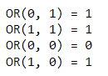

**AND GATE**

import numpy as np  
    
# define Unit Step Function  
def unitStep(v):  
    if v >= 0:  
        return 1  
    else:  
        return 0  
    
# design Perceptron Model  
def perceptronModel(x, w, b):  
    v = np.dot(w, x) + b  
    y = unitStep(v)  
    return y  
    
# AND Logic Function  
# w1 = 1, w2 = 1, b = -1.5  
def AND_logicFunction(x):  
    w = np.array([1, 1])  
    b = -1.5  
    return perceptronModel(x, w, b)  
    
# testing the Perceptron Model  
test1 = np.array([0, 1])  
test2 = np.array([1, 1])  
test3 = np.array([0, 0])  
test4 = np.array([1, 0])  
    
print("AND({}, {}) = {}".format(0, 1, AND_logicFunction(test1)))  
print("AND({}, {}) = {}".format(1, 1, AND_logicFunction(test2)))  
print("AND({}, {}) = {}".format(0, 0, AND_logicFunction(test3)))  
print("AND({}, {}) = {}".format(1, 0, AND_logicFunction(test4)))

**OUTPUT:**

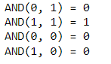

**SVM**

import numpy as np

import matplotlib.pyplot as plt

import pandas as pd

df = pd.read_csv('Social_Network_Ads.csv')

df.head()

df.shape

X = df.iloc[:, [2,3]]

Y = df.iloc[:, 4]

X.head()

Y.head()

# Splitting the dataset into the Training set and Test set

from sklearn.model_selection import train_test_split

X_Train, X_Test, Y_Train, Y_Test = train_test_split(X, Y, test_size = 0.25, random_state = 0)

print("Training data : ",X_Train.shape)

print("Training data : ",X_Test.shape)

 # Feature Scaling

from sklearn.preprocessing import StandardScaler

sc_X = StandardScaler()

X_Train = sc_X.fit_transform(X_Train)

X_Test = sc_X.transform(X_Test)

from sklearn.svm import SVC

classifier = SVC(kernel = 'linear', random_state = 0)

classifier.fit(X_Train, Y_Train)

# Predicting the test set results

Y_Pred = classifier.predict(X_Test)

Y_Pred

from sklearn import metrics

print('Accuracy Score: with linear kernel')

print(metrics.accuracy_score(Y_Test,Y_Pred))

import matplotlib.pyplot as plt

plt.scatter(X_Train[:, 0], X_Train[:, 1],c=Y_Train)

plt.xlabel('Age')

plt.ylabel('Estimated Salary')

plt.title('Training Data')

plt.show()

import matplotlib.pyplot as plt

plt.scatter(X_Test[:, 0], X_Test[:, 1],c=Y_Test)

plt.xlabel('Age')

plt.ylabel('Estimated Salary')

plt.title('Test Data')

plt.show()

**OUTPUT:**

